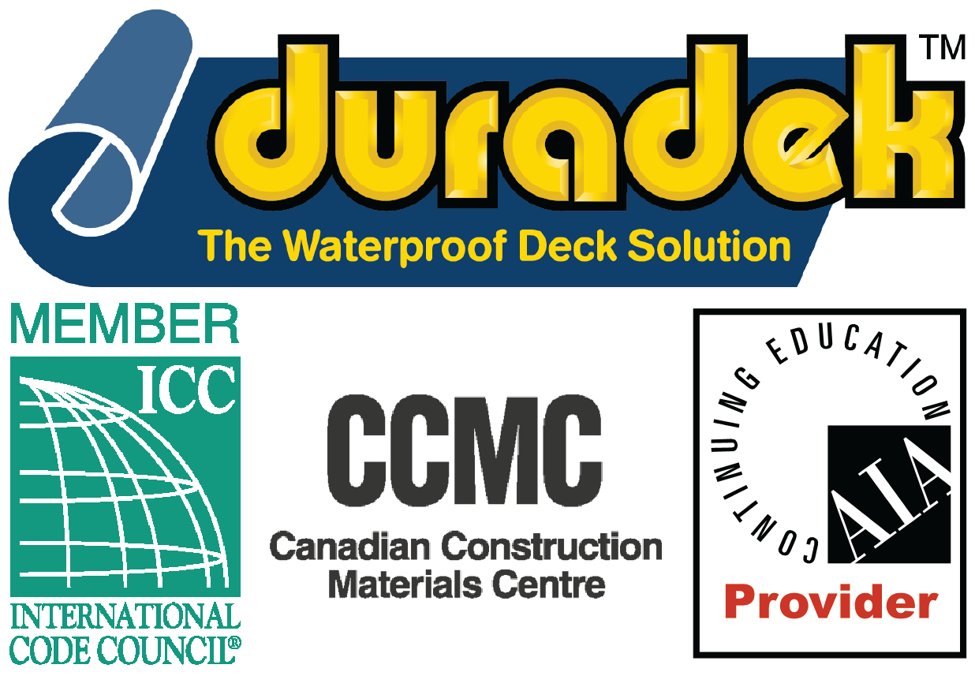

SECTION 07 18 13 - WATERPROOF PEDESTRIAN TRAFFIC COATING
SECTION 07 54 00 - THERMOPLASTIC MEMBRANE ROOFING
SECTION 07 54 19 - POLYVINYL-CHLORIDE ROOFING

Display hidden notes to specifier. (Don't know how? Click Here)
Copyright 2020 - All rights reserved

** NOTE TO SPECIFIER ** Duradek PVC waterproof traffic membrane for decks and other exterior horizontal surfaces.
This section is based on the products of Duradek/ Durarail - Waterproof Traffic Membranes and Powder Coated Aluminum Railings, which is located at:
Duradek/Durarail U.S. Inc.:
1722 Iron Street.
North Kansas City, MO 64116.
Toll Free: 800-338-3568.
Phone: 816-421-5830
Fax: 816 421-2924
Email: duradekus@duradek.com
Web: www.duradek.com.
Duradek/Durarail Canada Ltd.:
8288 129th Street.
Surrey, BC V3W 0A6 Canada.
Toll Free: 866-591-5594.
Phone: 604-591-5594
Fax: 604 591-3100.
Email: duradek@duradek.com.
Web: www.duradek.com.
[Click Here] for additional information.
Duradek is the original waterproof traffic membrane and has been solving waterproofing problems throughout North America since 1974. Duradek is suitable for waterproofing horizontal surfaces over habitable spaces, provided they are subject to not more than pedestrian traffic.
- GENERAL
  - SECTION INCLUDES
** NOTE TO SPECIFIER ** Delete items below not required for project. Add others as required.
    - Traffic membrane, consisting of welded seam PVC roofing membrane, over the following surfaces as indicated on the Drawings:
      - Balconies, sundecks and roof decks.
      - Walkways and stairways.
      - Patios and courtyards.
      - Swimming pool and hot tub decks.
  - RELATED SECTIONS
** NOTE TO SPECIFIER ** Delete any sections below not relevant to this project; add others as required.
    - Section 07620 - Sheet Metal Flashing and Trim.
    - Section 07500 - Membrane Roofing.
    - Section 07710 - Manufactured Roof Specialties.
    - Section 15160 - Roof Drains.
  - REFERENCES
** NOTE TO SPECIFIER ** Delete references from the list below that are not actually required by the text of the edited section.
    - ASTM E 108 - Standard Test Methods for Fire Tests of Roof Coverings.
    - CAN/ULC-S107 - Standard Methods of Fire Tests of Roof Coverings.
    - CCMC - Technical Guide for PVC Sheet Waterproofing (Exposed to Light Pedestrian Traffic).
    - CGSB 37.54-95 - Roofing and Waterproofing Membrane, Sheet Applied, Flexible, Polyvinyl Chloride.
    - CGSB 37-GP-55M - Application of Sheet Applied Flexible Polyvinyl Chloride Roofing Membrane.
    - FBC 2017 - Compliance with Florida Building Commission Requirements.
    - ICC - Acceptance Criteria (AC39) for Walking Decks
    - ICC - Acceptance Criteria (AC75) for Membrane Roof Covering Systems
    - TDI RC-477 - Meets Texas Department of Insurance Requirements.
    - UBC Std 15-2 - Test Standard for Determining the Fire Retardancy of Roof-covering Materials.
  - SUBMITTALS
    - Submit under provisions of Section 01300.
    - Product Data: Manufacturer's data sheets on each product to be used, including:
      - Preparation instructions and recommendations.
      - Storage and handling requirements and recommendations.
      - Installation methods.
    - Shop Drawings: Installation and seaming plan, showing joints, termination details, and interface with other materials.
    - Verification Samples: Two 8-1/2 by 11 inch (210 by 250 mm) pieces showing finish, pattern, color, and backing with label.
    - Manufacturer's Certificates: Certify products meet or exceed specified requirements.
  - QUALITY ASSURANCE
    - Manufacturer Qualifications: Company specializing in providing products of the type specified in this section, with minimum of 25 years documented experience with products in use.
    - Installer Qualifications: Company specializing in installing products of the type specified with trained installer and currently authorized by manufacturer.
    - Pre-installation Meeting: Meeting to discuss waterproofing practices and precautions applicable to this project.
      - Convene minimum of 7 days prior to start of installation.
      - Require the attendance of:
        - Manufacturer's representative.
        - Contractor's field superintendent.
        - Installation foreman.
        - Other trades affected by this work.
        - Owner's representative.
  - DELIVERY, STORAGE, AND HANDLING
    - Deliver and store products in manufacturer's original containers, dry and undamaged, with seals and labels intact until ready for installation.
      - Label uncured materials, both sheets and canned goods, with date of manufacturer and shelf life.
      - Do not use creased or damaged sheets.
      - Do not use products after end of shelf life.
    - Store and handle materials to prevent damage.
      - Place materials on pallets.
      - Prevent creasing of rolled materials.
      - Do not use polyethylene to cover stored materials (canvas tarpaulins are acceptable).
      - Keep containers closed, except when removing materials from them.
    - Keep materials at temperature between 40 degrees F (4.4 degrees C) and 80 degrees F (26.6 degrees C); if adhesives are exposed to lower temperature, verify useability with manufacturer before using.
  - PROJECT CONDITIONS
    - Maintain environmental conditions (temperature, humidity, and ventilation) within limits recommended by manufacturer for optimum results. Do not install products under environmental conditions outside manufacturer's recommended limits.
  - WARRANTY
    - Provide manufacturer's 15-year warranty for membrane leaks due to a manufacturing defect, covering materials, and/or repair and replacement labor.
- PRODUCTS
  - MANUFACTURERS
** NOTE TO SPECIFIER ** Delete one of the following two paragraphs; the first is the US company, the second is the Canadian.
    - Manufacturer: Provide products of Duradek/Durarail U.S. Inc., 1142 Clay Street, North Kansas City, MO 64116. Toll Free Tel: 800-338-3568. Tel: 816-421-5830. Fax: 816-421-2924. Email: duradekus@duradek.com ; Website: www.duradek.com.
    - Manufacturer: Provide products of Duradek/Durarail Canada Ltd., 8288 129th Street, Surrey, BC V3W 0A6 Canada. Toll Free Tel: 866-591-5594. Tel: 604-591-5594. Fax: 604-591-3100. Email: duradek@duradek.com ; Website: www.duradek.com.
** NOTE TO SPECIFIER ** Delete one of the following two paragraphs; coordinate with requirements of Division 1 section on product options and substitutions.
    - Substitutions: Not permitted.
    - Requests for substitutions will be considered in accordance with provisions of Section 01600.
  - MATERIALS
    - Traffic Membrane: Duradek Ultra; polyester reinforced PVC membrane with ultra-violet resistance, for fully-adhered installation with heat-welded seams and perimeter attachment.
      - Sheet Width: 72 inches (1828.8mm).
      - Overall Sheet Thickness: 0.060 inch (1.5 mm).
      - PVC Film Thickness: 0.050 inch (1.3 mm).
      - Weight: 55 oz/sq yd (1864 g/sq m).
      - Color:
** NOTE TO SPECIFIER ** Select one of the following color paragraphs and delete those not required.
        - Ultra: Arctic Quartz.
        - Ultra: Desert Quartz.
        - Ultra: Pebble Beach.
        - Ultra Legacy: Barnwood.
        - Ultra Legacy: Driftwood.
        - Ultra Legacy: Cedarwood.
        - Ultra Forest Floor: Birch.
        - Ultra Forest Floor: Alder.
        - Ultra Forest Floor: Ash.
        - Ultra Cork: Espresso.
        - Ultra Cork: Macchiato.
        - Ultra Cork: Graphite.
        - Ultra Heritage: Agate.
        - Ultra Heritage: Aspen.
        - Ultra Heritage: Sienna.
        - Ultra Heritage: Sunrise.
        - Ultra Supreme Chip: Granite.
        - Ultra Supreme Chip: Taupe.
        - Ultra Supreme Chip: Sonoma.
        - Ultra Classic: Sandstone.
        - Ultra Classic: Steel.
        - Ultra Surcoseal: Grey.
        - Ultra Surcoseal: Suede.
        - Ultra Okanagan: Flint.
        - Ultra Okanagan: Leather.
        - Ultra Okanagan: Linen.
        - As selected by Architect.
      - Slip Resistance: Tested to meet ADA requirements.
** NOTE TO SPECIFIER ** Select one of the following two paragraphs and delete the one not required.
      - Flammability (ASTM E 108 and UBC Std 15-2): Class A, when installed over non-combustible substrate.
      - Flammability (CAN/ULC-S107): Class A, when installed over non-combustible substrate.
      - Flammability (ASTM E 108 and UBC Std 15-2): Class C, when installed over combustible plywood substrate.
      - Flammability (CAN/ULC-S107): Class C, when installed over combustible plywood substrate.
** NOTE TO SPECIFIER ** Include the following paragraphs for International Building Code approval (US). Delete if not required. Complete test reports are available upon request.
      - International Building Code Compliance: Comply with 2015 International Building Code requirements for walking decks and ICC Acceptance Criteria for Walking Decks, as evidenced by current Evaluation Report prepared by ICC Evaluation Service (ICC-ES).
      - International Building Code Compliance: Comply with 2015 International Building Code requirements for walking decks and ICC Acceptance Criteria for Membrane Roof Covering Systems, as evidenced by current Evaluation Report prepared by ICC Evaluation Service (ICC-ES).
** NOTE TO SPECIFIER ** Include the following three paragraphs for Canadian requirements. Delete any of that are not applicable. Complete test reports are available upon request.
      - Comply with CAN/CGSB-37.54.
      - National Building Code of Canada Compliance: Comply with National Building Code of Canada 2015, Part 9, Clause 9.26.2.1(1)(h), and CCMC Technical Guide for PVC Sheet Waterproofing (Exposed to Light Pedestrian Traffic), as evidenced by current Evaluation Report prepared by National Research Council, Canada Construction Materials Centre (CCMC).
      - CMHC Approval: Approved by Canada Mortgage and Housing Corporation for use in construction financed or insured under the National Housing Act.
    - Miscellaneous Accessories:
      - Provide PVC Coated Metal, Scuppers, Overflow Drains, Roof Drains, and Trims as required for proper installation.
      - Provide Surface Conditioners, Adhesives, Sealants, Fillers, and Cleaners as required for proper installation.
      - Provide mechanical fastening devices color coordinated to membrane color.
    - Adjacent Flashings: Coordinate with flashing specified in Section 07620.

- EXECUTION
  - EXAMINATION
    - Do not begin installation until substrates have been properly prepared.
    - Verify that deck is:
** NOTE TO SPECIFIER ** Architect must verify the adequacy of the structural support including dead and potential live loads for all surfaces to receive membrane.
      - Secure, well supported, solid, and in accordance with local code structural requirements.
** NOTE TO SPECIFIER ** Minimum required slope is 1 in 100, or 1/8 inch per foot, with an optimum of 1 in 50. 1 in 50 slope, or 1/4 inch in 12 inches, is recommended for all new construction. Coordinate with Drawings to verify proper slopes. For existing construction coordinate details with manufacturer.
      - Properly sloped to drains, valleys, or eaves.
      - Clean and smooth, free of depressions, waves, and projections.
      - Dry and free of ice and snow.
    - If substrate preparation is the responsibility of another installer, notify Architect of unsatisfactory preparation before proceeding.
  - PREPARATION
    - Clean surfaces thoroughly prior to installation.
    - Coordinate timing of installation to avoid construction traffic over completed traffic membrane surfaces.
** NOTE TO SPECIFIER ** If wood deck is to be the substrate, delete one of the following two paragraphs. The first is for wood deck without any overlay - combustible. The second is for a non-combustible application. The minimum wood deck that is acceptable is 5/8 inch thick exterior plywood, CDX grade, with tongue-and-groove edges.
    - Wood Deck: Fill joints, knot holes, voids, and low areas with filler and sand smooth.
    - Wood Deck: Cover with cementitious board meeting requirements of Class A approved application. Fill joints, knot holes, voids, and low areas with filler and sand smooth.
** NOTE TO SPECIFIER ** Concrete deck shall be fully cured and have a steel troweled finish.
    - Concrete Deck: Fill surface imperfections and variations with leveling compound. Test for and remove surface contaminants.
    - Coordinate installation with installation of drains and similar accessories.
    - Install flashings and accessories. Seal around all penetrations, drains, and edges.
    - Membrane shall not come in contact with bituminous materials or polystyrene insulations. Contact manufacturer for additional information.
    - Prepare surfaces using the methods recommended by the manufacturer for achieving the best result for the substrate under the project conditions.
  - INSTALLATION
    - Install in accordance with manufacturer's instructions and applicable codes.
** NOTE TO SPECIFIER ** Include the following paragraph for Canadian installations. Delete if not applicable.
    - Install in accordance with CGSB-37-GP-55M.
    - Do not install when temperature is below 25 degrees F (minus 3.8 degrees C) or above 98 degrees F (36.6 degrees C). Do not install when winds are gusting over 30 mph (48.3 kph).
    - Do not dilute primers, adhesives, coatings, or sealants.
    - Install membrane with minimum number of seams possible. Overlap seams 3/4 inch (19 mm), to shed water; heat-weld all seams.
    - Adhere membrane to substrate.
    - Mechanically fasten all perimeter edges and penetrations.
  - CLEANING
    - Clean soiled areas in accordance with manufacturer's recommendations.
  - PROTECTION
    - Protect installed products until completion of project.
    - Avoid construction traffic over completed traffic membrane surfaces.
    - Touch-up, repair or replace damaged products before Substantial Completion.

END OF SECTION

