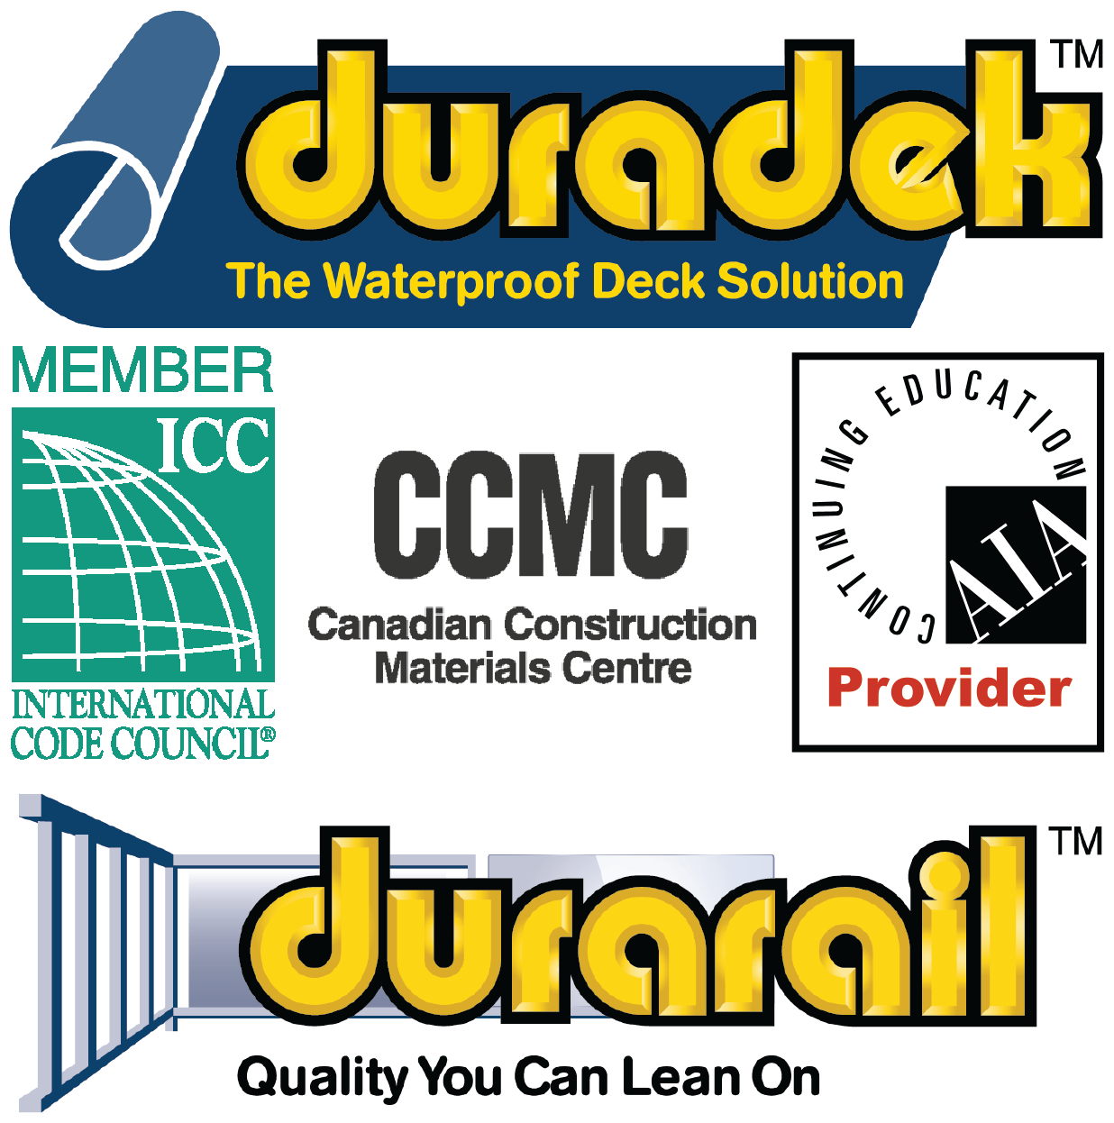

SECTION 05721 - ALUMINUM HANDRAILS AND RAILINGS
SECTION 05720 - ORNAMENTAL HANDRAILS AND RAILINGS
SECTION 05520 - HANDRAILS AND RAILINGS / METAL RAILINGS /
PIPE AND TUBE RAILNGS / ALUMINUM RAILINGS
SECTION 05521 - GLASS RAILINGS

Display hidden notes to specifier. (Don't know how? Click Here)

Copyright 2020 - All rights reserved

** NOTE TO SPECIFIER ** Durarail Aluminum Railings, ornamental aluminum railing and fence systems.
This section is based on the products of Duradek/Durarail - Waterproof Traffic Membranes and Powder Coated Aluminum Railings, which is located at:
Duradek/Durarail U.S. Inc.:
1722 Iron Street.
North Kansas City, MO 64116.
Toll Free: 800-338-3568.
Phone: 816-421-5830
Fax: 816 421-2924
Email: duradekus@duradek.com
Web: www.duradek.com.
Duradek/Durarail Canada Ltd.:
8288 129th Street.
Surrey, BC V3W 0A6 Canada.
Toll Free: 866-591-5594.
Phone: 604-591-5594
Fax: 604 591-3100.
Email: duradek@duradek.com.
Web: www.duradek.com.
[Click Here] for additional information.
Duradek provides the "Durarail" aluminum component railing system for new construction or remodeling, residential or commercial, manufactured exclusively for Duradek by Excell Railing Systems Ltd. Available in several rail profiles and several powder coated stock or custom colors, "Durarail" is designed for fast and versatile installation to fit any deck configuration. It is available in "view-through" tempered glass and traditional picket designs to meet all national building codes. Duradek also produces a large selection of powder coated aluminum fencing systems; contact Durarail for additional information and specifications.
- GENERAL
  - SECTION INCLUDES
** NOTE TO SPECIFIER ** Delete items below not required for project.
    - Aluminum handrails, guardrails, and railing systems, including connectors, fasteners, and required accessories including the following types and applications:
      - Glass baluster railing system.
      - Glass panel railing system.
      - Topless glass panel railing system.
      - Ornamental welded aluminum railing system.
      - Ornamental component aluminum railing system.
      - Pre-assembled aluminum and stainless-steel railing system (cable railing).
      - Handrail system.
      - Fencing system.
      - Gates.
      - Privacy screens.
      - Wind screens.
  - RELATED SECTIONS
** NOTE TO SPECIFIER ** Delete any sections below not relevant to this project; add others as required.
    - Section 03 30 00 - Cast-in-Place Concrete.
    - Section 05 51 33 - Metal Ladders.
    - Section 05 73 13 - Glazed Decorative Metal Railings.
    - Section 05 71 00 - Decorative Metal Stairs.
    - Section 06 20 00 - Finish Carpentry.
    - Section 06 43 13 - Wood Stairs.
    - Section ______ - ____________: Execution requirements for placement of anchors specified in this section in ________ wall construction.
  - DESIGN / PERFORMANCE REQUIREMENTS
    - Structural Performance: Engineer, fabricate, and install handrails, guardrails, and railing systems to withstand the structural loading required by applicable codes.
  - SUBMITTALS
    - Submit under provisions of Section 01 30 00 - Administrative Requirements.
    - Product Data: Manufacturer's data sheets on each product to be used, including:
      - Preparation instructions and recommendations.
      - Storage and handling requirements and recommendations.
      - Installation methods.
    - Shop Drawings:
      - Show complete layout; plan views, elevations, connections, details for fabrication and attachment to other elements, and other installation details.
      - Include sealed drawings by the registered engineer responsible for structural design of system.
** NOTE TO SPECIFIER ** Delete selection samples if colors have already been selected.
    - Selection Samples: For each finish product specified, two complete sets of color chips representing manufacturer's full range of available colors and patterns.
    - Verification Samples: For each finish product specified, two samples, minimum size 6 inches (150 mm) square, representing actual product, color, and patterns.
    - Manufacturer's Certificates: Certify products meet or exceed specified requirements.
    - Closeout Submittals: Provide manufacturer's maintenance instructions that include recommendations for periodic cleaning and maintenance of all railing components.
  - QUALITY ASSURANCE
    - Manufacturer Qualifications: Company specializing in providing products of the type specified in this section, with minimum of 15 years documented experience with products in use.
    - Installer Qualifications: Company specializing in installing products of the type specified.
  - DELIVERY, STORAGE, AND HANDLING
    - Deliver handrails, guardrails, railing systems, and related components in protective packaging.
    - Store components to avoid damage from abrasion and other construction activities.
  - SEQUENCING
    - Ensure that locating templates and other information required for installation of products of this section are furnished to affected trades in time to prevent interruption of construction progress.
  - PROJECT CONDITIONS
    - Maintain environmental conditions (temperature, humidity, and ventilation) within limits recommended by manufacturer for optimum results. Do not install products under environmental conditions outside manufacturer's recommended limits.
  - WARRANTY
** NOTE TO SPECIFIER ** Delete one of the following two paragraphs; the first is for residential projects, the second is for commercial projects.
    - Manufacturer's Limited 20-Year Residential Warranty: provide manufacturer's standard residential limited warranty for defects in the structure and weld for 20 years; and protection against cracking, peeling, flaking or blistering for 10 years.
    - Manufacturer's Limited 20-Year Commercial Warranty: provide manufacturer's standard commercial limited warranty for defects in the structure and weld for 20 years; and protection against cracking, peeling, flaking or blistering to be determined per project.
- PRODUCTS
  - MANUFACTURERS
** NOTE TO SPECIFIER ** Delete one of the following two paragraphs; the first is the US company, the second is the Canadian.
    - Manufacturer: Excell Railings Systems Ltd
#306 – 12886 Anvil Way, Surrey, BC V3W 8E7 Canada. Toll Free Tel: 1-866-999-7245. Tel: 604-501-0151. Fax: 604-501-0155. Email: info@excellrailing.com; Website: https://excellrailing.com/
      - Manufacturer: Excell Railings Systems Ltd. exclusively provides Durarail brand for products of Duradek/Durarail U.S. Inc., 1142 Clay Street, North Kansas City, MO 64116. Toll Free Tel: 800-338-3568. Tel: 816-421-5830. Fax: 816-421-2924. Email: duradekus@duradek.com; Website: www.duradek.com.

      - Manufacturer: Excell Railings Systems Ltd exclusively provides Durarail brand for products of Duradek/Durarail Canada Ltd., 8288 129 Street, Surrey, BC V3W 0A6 Canada. Toll Free Tel: 1-866-591-5594. Tel: 604-591-5594. Fax: 604-591-3100. Email: duradek@duradek.com; Website: www.duradek.com.
** NOTE TO SPECIFIER ** Delete one of the following two paragraphs; coordinate with requirements of Division 1 section on product options and substitutions.
    - Substitutions: Not permitted.
    - Requests for substitutions will be considered in accordance with provisions of Section 01 60 00 - Product Requirements.
  - HANDRAILS AND RAILINGS
    - General: Provide products free from surface blemishes where exposed to view in the finished installation.
    - Aluminum Handrail and Railing Systems: Durarail
** NOTE TO SPECIFIER ** Select designs from the following subparagraphs or insert a custom design, deleting those paragraphs not required for the project. In each design the top rail runs continuously over each support post and bottom rails are attached to the post at post interruption locations.
      - Design: Component Picket System.
      - Design: Component Glass System.
      - Design: Welded Picket System.
      - Design: Topless Glass Mirage Post system.
      - Design: Topless Glass PUP Post system.
      - Design: Cable Railing.
      - Design: _________________________________.
** NOTE TO SPECIFIER ** Select stock color from the following eight paragraphs, deleting those not required for the project, or delete all stock colors and insert custom color. Coordinate custom colors with the manufacturer. Premium Wood Finish is available in 22 different wood grains.
      - Color: White.
      - Color: Textured White.
      - Color: Black.
      - Color: Textured Black
      - Color: Rideau Brown.
      - Color: Textured Rideau Brown.
      - Color: Beige.
      - Color: Quartz Grey.
      - Color: Grey.
      - Color: Textured Grey.
      - Color: Sandalwood.
      - Color: Oyster Grey.
      - Color: Premium Wood Grain Finish, color as selected by the Architect.
      - Color: Premium Wood Grain Finish, color ____.
      - Color: Custom: ______________________.
  - COMPONENTS
    - General: Provide all aluminum components of same alloy.
    - Posts: Aluminum, sizes indicated on the Drawings; welded bases.
    - Rails: Aluminum, sizes indicated on approved shop drawings.
      - Top rails continuous over posts.
** NOTE TO SPECIFIER ** Select profile from the following subparagraphs, unless shown on the Drawings. Contact the manufacturer for custom profiles and insert description, if required. Delete profiles not required for the project, or delete all profile subparagraphs if detailed on the Drawings. Cable railing is available with 5 standard Durarail top profiles.
        - Profile: Round.
        - Profile: Square.
        - Profile: Port Royal.
        - Profile: Heritage.
        - Profile: PUP - No Top Rail.
        - Profile: Cable Railing with ____________.
        - Profile: _________________________.

      - Bottom Rail Profiles: Unspliced lengths between posts.
** NOTE TO SPECIFIER ** Refer to Durarail product catalog for the profiles below. Select profile from the following subparagraphs. Insert custom profile description in the fifth subparagraph, if required. Delete profiles not required or delete all profile subparagraphs if detailed on the drawings.
        - Profile. Welded Picket.
        - Profile. Component Glass.
        - Profile: Fence Bottom Sleeve.
        - Profile: Glazing Channel.
        - Profile: ______________________________.
** NOTE TO SPECIFIER ** Edit the following four paragraphs to include only the infill required and delete those not required.
    - Pickets: Aluminum, sizes indicated on the Drawings.
** NOTE TO SPECIFIER ** Collapsible pickets are for use for adjustable stair rails. Collapsible, pre-assembled panels means no need to install individual pickets on site and no need to wait for the stairs to be built for measurement as they adjust to virtually any angle. Delete if not required.
    - Collapsible Pickets: Aluminum:
** NOTE TO SPECIFIER ** Select the sizes required and delete those not required.
      - Height: 36 inches.
      - Height: 42 inches.
      - Length: 6 feet.
      - Length: 8 feet.
      - Length: 10 feet.
    - Cable and Hardware: 1/8 inch, Type 316 stainless steel cable and fittings.
** NOTE TO SPECIFIER ** Include the following paragraph if glass panel inserts are required for the project. Clear tempered glass is standard, tinted tempered is optional; delete whichever subparagraph is not required. If tinted is selected, indicate tint color.
    - Panels: 1/4 inch (6 mm) tempered glass.
      - Clear.
      - ____________ tinted.
  - ACCESSORlES
** NOTE TO SPECIFIER ** Delete one of the following two paragraphs.
    - Screws: Color matched, stainless steel.
    - Screws: Color matched, cadmium plated.
    - Anchors and Inserts: As required to support work specified, in accord with approved shop drawings.
    - Fittings and Fasteners: Same basic material as parts being joined, unless otherwise indicated. Do not use metals corrosive or incompatible with materials being fastened.
  - FABRlCATlON
    - Fabricate handrails and railing systems to comply with manufacturer's printed requirements, project design requirements, details, dimensions, finish and member sizes, including post spacing and anchorage, but not less than the structural requirements to support loading.
    - Clearly mark component units for site assembly and installation.
    - Use connections that maintain structural capacity of joined members.
  - FINISH
    - Powder Coated Finish: Factory electrostatically-applied, color as specified.
    - Premium Wood Finish: Factory applied, color as specified. Conforms to AAMA 2604.

- EXECUTION
  - EXAMINATION
    - Do not begin installation until substrates have been properly prepared.
    - If substrate preparation is the responsibility of another installer, notify Architect of unsatisfactory preparation before proceeding.
  - PREPARATION
    - Prepare surrounding construction to receive railing system installations to comply with manufacturer's requirements.
    - Review and coordinate setting drawings, shop drawings, templates, and instructions for assembly and installation of railing system and related items to be embedded in concrete and masonry.
  - INSTALLATION
    - Install railing system and related components in strict accordance with manufacturer's printed installation instructions and approved project shop drawings.
    - Preassemble railing system, including posts, pickets, and panels where shown, in easy to lift sections whenever possible.
      - Align rails so that variations from level for horizontal members, and from parallel with rake of steps and ramps for sloping members, do not exceed 1/4 inch in 12 feet (6 mm in 3.65 m).
      - Separate aluminum from building materials where electrolytic action may occur by means of asphaltic paint or other approved method.
    - Adjust, level, and securely install railing system components.
    - Install bottom rails in unspliced lengths between posts.
    - Install posts of continuous sections from mounting base to top rail.
  - CLEANING
    - Immediately upon completion of installation, clean all railing system surfaces using clean water and mild soap or detergent.
    - Do not use abrasive agent or harsh chemicals.
  - PROTECTION
    - Protect installed products until completion of project.
    - Touch-up, repair or replace damaged products before Substantial Completion.

END OF SECTION

